a. The YTD in the Table represent the customer who is about to buy something from the Ecommerce

b.the decision that is taken how a customer service will help deliver a product to thier custosmers

c. for a customer to get no charge for a her GOODS of $240 she have to incresss to $250 and and product must be more or equal to 4 to get no charge

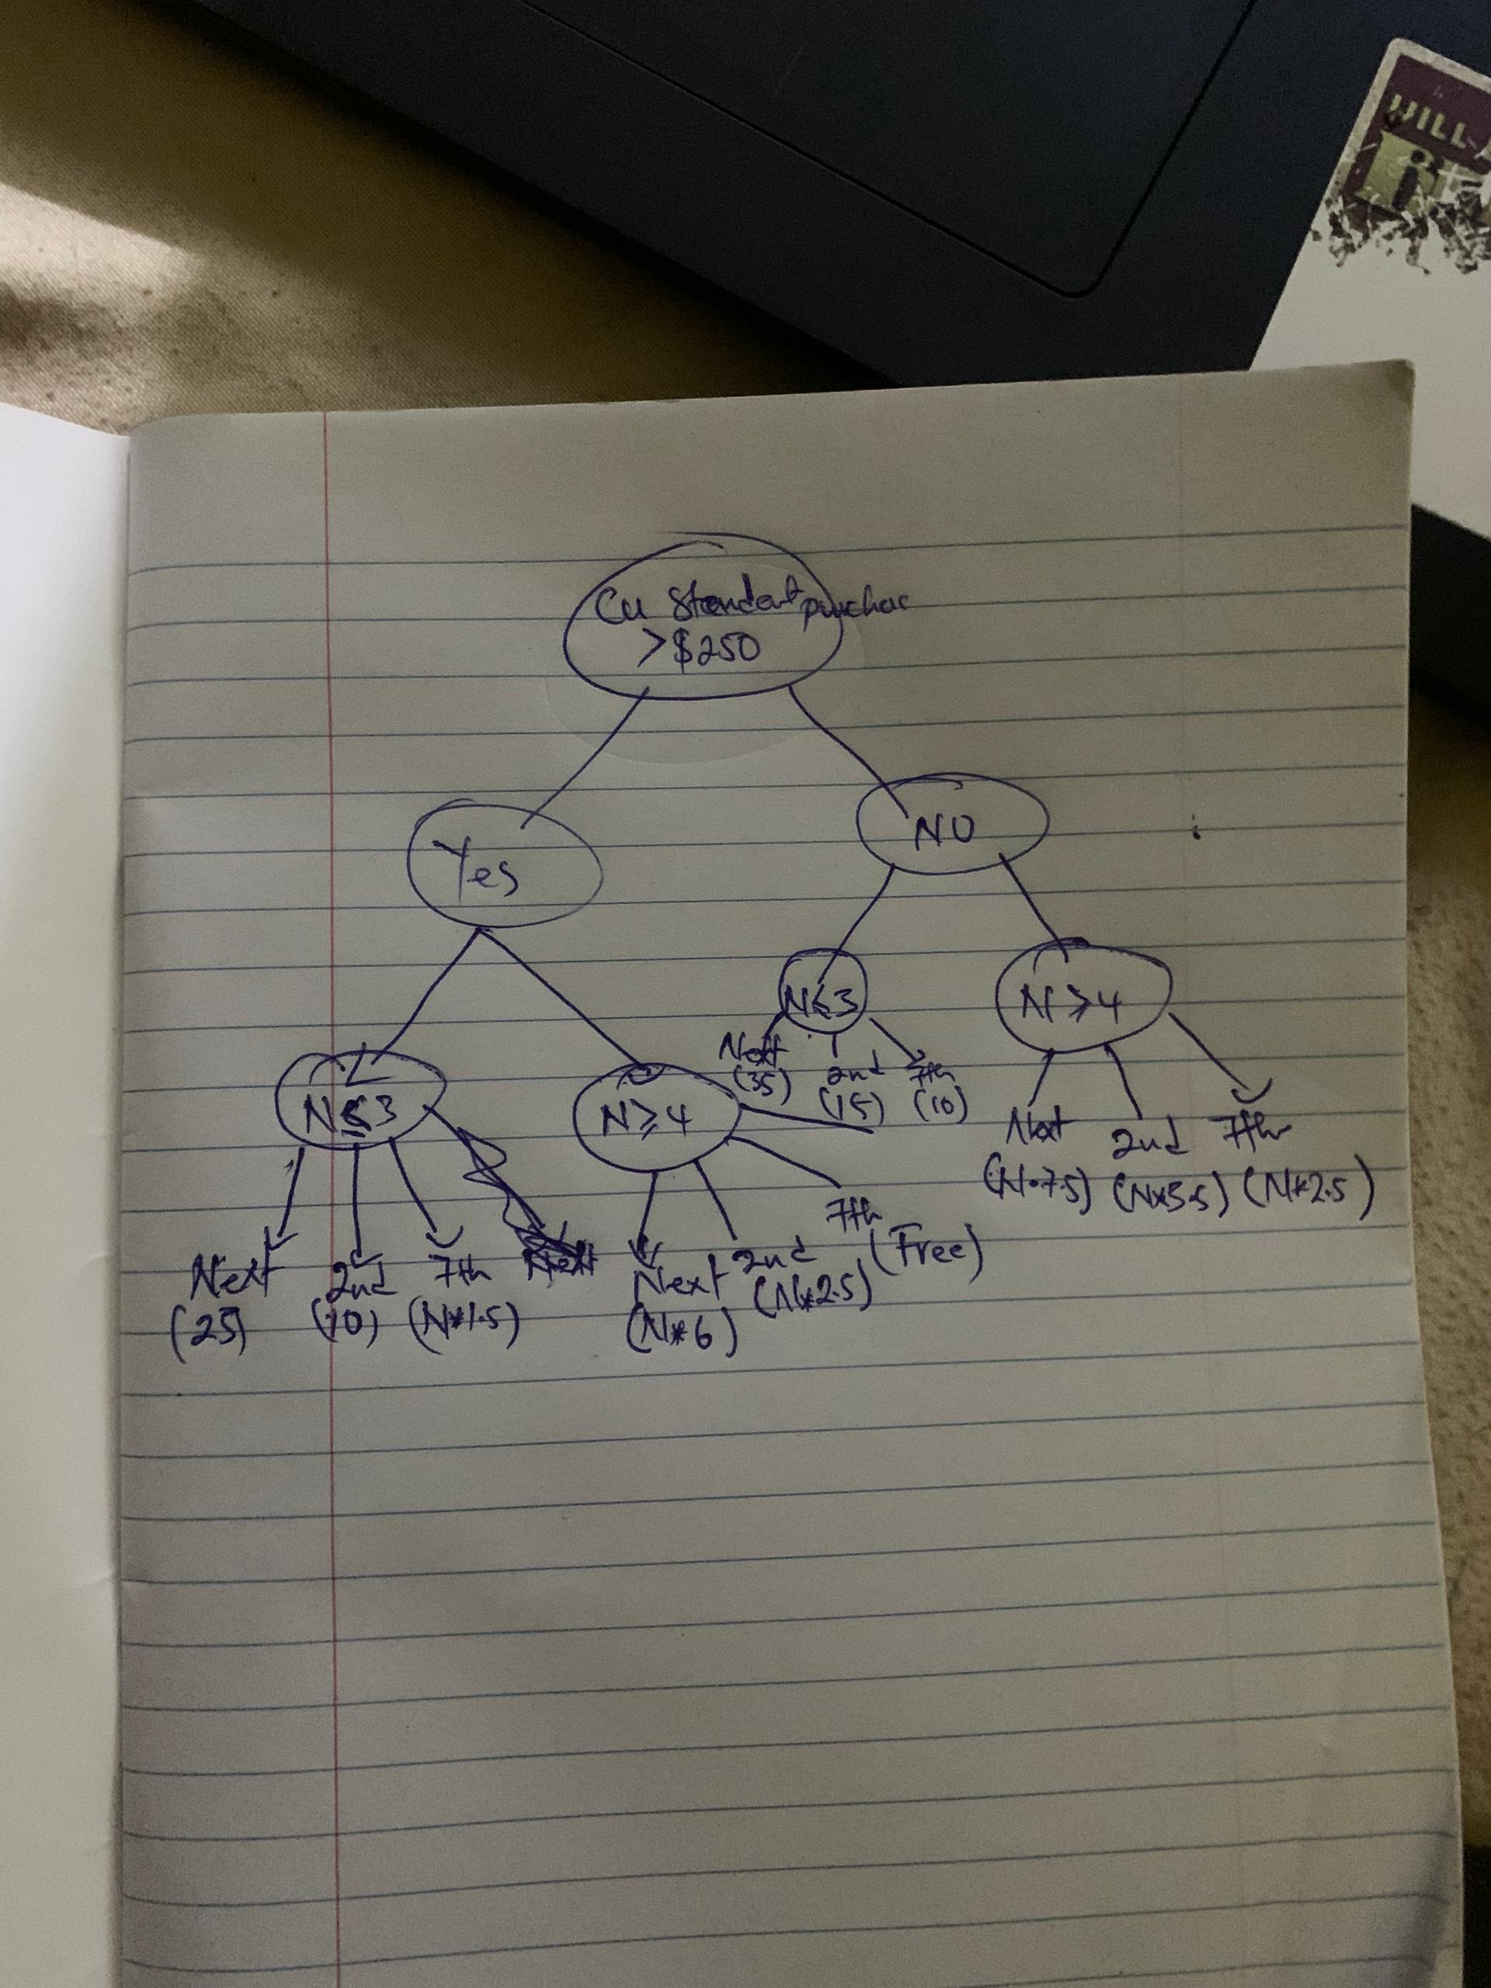

e

**.      What is a Decision Support System (DSS)?**

**b.     What are the main components of a DSS?**

**c.      How does a DSS differ from a traditional information system?**

**d.     What types of decisions can a DSS assist with?**

**e.      Give an example of a DSS application.**

**f.      What are the benefits of using a DSS?**

**a. What is a Decision Support System (DSS)?**

**A Decision Support System (DSS) is a computer-based information system designed to assist decision-makers in making informed and effective decisions. It combines data, analytical tools, and models to support semi-structured or unstructured decision-making processes. DSS is not meant to replace human judgment but to enhance it by providing relevant information and analysis.**

**b. What are the main components of a DSS?**

**The main components of a DSS include:**

1. **Data Management Module: Stores and manages data from internal and external sources.**
2. **Model Management Module: Contains mathematical and analytical models for decision-making (e.g., optimization, simulation).**
3. **User Interface (UI): Allows users to interact with the system, input data, and view results.**
4. **Knowledge Base: Stores rules, expertise, and guidelines to support decision-making.**
5. **User/Decision-Maker: The individual or group using the system to make decisions.**

**c. How does a DSS differ from a traditional information system?**

* **Purpose: A DSS is specifically designed to support decision-making, while traditional information systems focus on data processing and routine tasks (e.g., transaction processing).**
* **Flexibility: DSS is more flexible and adaptable to unstructured or semi-structured problems, whereas traditional systems are often rigid and designed for structured tasks.**
* **User Interaction: DSS emphasizes user interaction and exploration of data, while traditional systems typically automate predefined processes.**
* **Output: DSS provides analytical insights and recommendations, while traditional systems generate reports or process transactions.**

**d. What types of decisions can a DSS assist with?**

**A DSS can assist with:**

* **Strategic Decisions: Long-term planning (e.g., market expansion, investment decisions).**
* **Tactical Decisions: Medium-term planning (e.g., resource allocation, budgeting).**
* **Operational Decisions: Day-to-day activities (e.g., inventory management, scheduling).**
* **Unstructured Decisions: Complex problems with no clear solution (e.g., crisis management).**
* **Semi-Structured Decisions: Problems with some structured elements but requiring judgment (e.g., sales forecasting).**

**e. Give an example of a DSS application.**

**An example of a DSS application is a sales forecasting system used by a retail company. It analyzes historical sales data, market trends, and external factors (e.g., weather, holidays) to predict future sales. This helps managers make informed decisions about inventory levels, staffing, and marketing strategies.**

**f. What are the benefits of using a DSS?**

1. **Improved Decision-Making: Provides accurate, timely, and relevant information.**
2. **Efficiency: Reduces the time and effort required to analyze data.**
3. **Flexibility: Adapts to different types of decisions and user needs.**
4. **Better Collaboration: Facilitates communication and collaboration among decision-makers.**
5. **Risk Reduction: Helps identify risks and evaluate alternatives before making decisions.**
6. **Cost Savings: Optimizes resource allocation and reduces operational costs.**
7. **Competitive Advantage: Enables organizations to respond quickly to market changes and opportunities.**

***Question3***

***a.     Explain the role of a Decision Support System (DSS) in modern business organizations. How does it contribute to decision-making processes?***

***b.     Discuss the key components of a Decision Support System (DSS) and their functions. How do these components work together to support decision-making?***

**. Role of a Decision Support System (DSS) in Modern Business Organizations**

**A Decision Support System (DSS) plays a critical role in modern business organizations by enhancing the quality, speed, and effectiveness of decision-making processes. Its contributions include:**

1. **Data-Driven Insights: DSS provides access to relevant data from multiple sources, enabling decision-makers to base their choices on accurate and comprehensive information.**
2. **Support for Complex Decisions: It helps tackle unstructured or semi-structured problems by offering analytical tools and models to evaluate scenarios and alternatives.**
3. **Improved Efficiency: Automates data analysis, reducing the time and effort required to process information manually.**
4. **Enhanced Collaboration: Facilitates communication among teams by providing a shared platform for data analysis and decision-making.**
5. **Risk Management: Identifies potential risks and evaluates the impact of different decisions, helping organizations mitigate uncertainties.**
6. **Strategic Planning: Assists in long-term planning by forecasting trends, analyzing market conditions, and simulating outcomes.**
7. **Adaptability: Allows organizations to respond quickly to changing business environments by providing real-time or near-real-time insights.**

**In summary, a DSS empowers organizations to make informed, data-backed decisions, leading to improved performance, competitiveness, and innovation.**

**b. Key Components of a Decision Support System (DSS) and Their Functions**

**A DSS consists of several interconnected components that work together to support decision-making. The key components and their functions are:**

1. **Data Management Module:**
   * **Function: Stores, retrieves, and manages data from internal (e.g., databases, ERP systems) and external sources (e.g., market data, social media).**
   * **Role: Provides the raw material for analysis and ensures data accuracy and accessibility.**
2. **Model Management Module:**
   * **Function: Contains analytical and mathematical models (e.g., optimization, simulation, forecasting) to process data and generate insights.**
   * **Role: Enables users to evaluate different scenarios, predict outcomes, and make data-driven recommendations.**
3. **User Interface (UI):**
   * **Function: Provides an interactive platform for users to input data, query the system, and view results in a user-friendly format (e.g., dashboards, charts, reports).**
   * **Role: Ensures ease of use and accessibility for decision-makers, regardless of their technical expertise.**
4. **Knowledge Base:**
   * **Function: Stores rules, expertise, and guidelines (e.g., business rules, best practices) to support decision-making.**
   * **Role: Enhances the system's ability to provide context-specific recommendations and insights.**
5. **User/Decision-Maker:**
   * **Function: The individual or group interacting with the DSS to make decisions.**
   * **Role: Brings human judgment and expertise to interpret the system's outputs and make final decisions.**

**How These Components Work Together**

* **The Data Management Module collects and organizes data, which is then processed by the Model Management Module using analytical tools and models.**
* **The results of the analysis are presented to the user through the User Interface, which allows for interactive exploration and visualization of data.**
* **The Knowledge Base provides additional context and rules to refine the analysis and recommendations.**
* **Finally, the User/Decision-Maker interprets the insights, applies their expertise, and makes informed decisions.**

***Describe the benefits and challenges of implementing a Decision Support System (DSS) in an organization. How can organizations address these challenges to maximize the benefits of a DSS?***

**Benefits of Implementing a Decision Support System (DSS)**

1. **Enhanced Decision-Making Quality**
   * **Benefit:** DSS provides accurate, data-driven insights and supports evidence-based decision-making. By analyzing large datasets and running simulations, decision-makers can evaluate multiple scenarios and choose the best course of action.
2. **Increased Efficiency**
   * **Benefit:** Automation of routine data collection and analysis tasks reduces time spent on manual processing, allowing decision-makers to focus on strategic actions.
3. **Improved Collaboration**
   * **Benefit:** Many DSS tools allow teams to collaborate by sharing dashboards, reports, and models, fostering better communication and group decision-making.
4. **Better Problem-Solving**
   * **Benefit:** DSS tools can analyze complex problems, simulate "what-if" scenarios, and optimize solutions that might be difficult to achieve manually.
5. **Real-Time Insights**
   * **Benefit:** Real-time data analysis enables quick responses to dynamic business conditions, such as supply chain disruptions or market shifts.
6. **Competitive Advantage**
   * **Benefit:** Organizations with DSS capabilities can adapt more quickly, identify trends, and capitalize on opportunities faster than competitors.

**Challenges of Implementing a DSS**

1. **High Implementation Costs**
   * **Challenge:** Developing, deploying, and maintaining a DSS requires significant financial investment in hardware, software, and skilled personnel.
2. **Data Quality Issues**
   * **Challenge:** Poor data quality, incomplete datasets, or inconsistencies can undermine the accuracy and reliability of the DSS outputs.
3. **Complexity of Integration**
   * **Challenge:** Integrating a DSS with existing IT systems, databases, and workflows can be technically challenging and time-consuming.
4. **Resistance to Change**
   * **Challenge:** Employees and managers may resist adopting a new system due to a lack of familiarity or fear of redundancy.
5. **Over-Reliance on Technology**
   * **Challenge:** Decision-makers may become overly dependent on the DSS, neglecting their judgment, intuition, or domain expertise.
6. **Security and Privacy Concerns**
   * **Challenge:** Storing and analyzing sensitive organizational data in the DSS introduces risks of data breaches and privacy violations.
7. **Training Requirements**
   * **Challenge:** Employees need proper training to effectively use the DSS, which can be costly and time-intensive.

**Addressing Challenges to Maximize Benefits**

1. **Cost Management**
   * Start small with a modular DSS that can scale over time.
   * Opt for cloud-based or SaaS solutions to reduce upfront infrastructure costs.
2. **Ensuring Data Quality**
   * Implement robust data validation and cleaning processes.
   * Regularly update and maintain data sources to ensure accuracy.
3. **Simplifying Integration**
   * Use middleware or APIs to connect the DSS with existing systems.
   * Involve IT experts in the planning phase to ensure compatibility.
4. **Change Management**
   * Engage employees early in the implementation process and communicate the benefits of the DSS.
   * Provide incentives for adoption and emphasize how it complements their roles.
5. **Balancing Technology with Human Expertise**
   * Encourage decision-makers to use DSS insights as a supplement, not a replacement, for their judgment.
   * Provide training on interpreting DSS outputs critically.
6. **Strengthening Security Measures**
   * Use encryption, access controls, and regular security audits to protect data.
   * Comply with industry-specific data protection regulations.
7. **Employee Training and Support**
   * Invest in comprehensive training programs to ensure users understand the system’s features.
   * Offer ongoing support and troubleshooting resources.